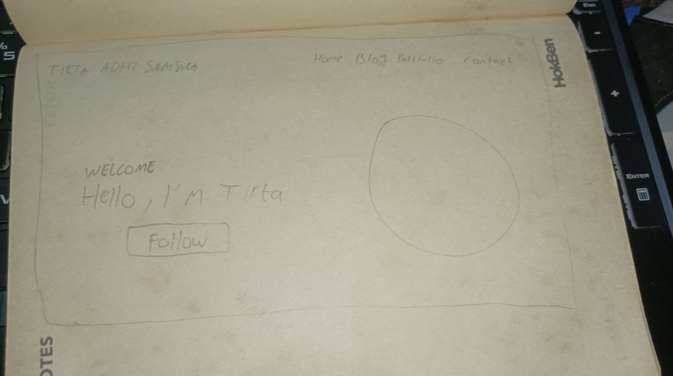

Link Wireframe figma:

<https://www.figma.com/file/zqnVkn6Ndk6yc0QRVf4iXa/wireframe-VSGA?type=design&node-id=0%3A1&mode=design&t=KihmsaHFP6GJmMVp-1>

Link MockUp figma:

<https://www.figma.com/file/fvzwwLEANcjaUArCVPftuX/mockupweb-VSGA?type=design&node-id=0%3A1&mode=design&t=PBdQnrRz3VgoL4MH-1>